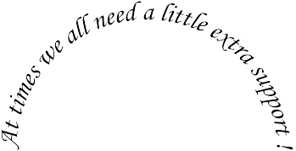Vaughan Community Service, Inc.
A Mission of the First Church of Christ, Congregational

PO Box 401
2503 White Mountain Highway North Conway, NH 03860
phone: (603) 356-2324 fax: (603) 356-7104
Email: Denise@VaughanNH.com

April 18, 2018

Dear Business Owner:

Vaughan Community Services is holding its 6th Annual Strawberry Festival on Saturday, June 30, 2018 at 2503 White Mountain Highway, North Conway. Strawberry shortcake, strawberry smoothies, and chocolate dipped strawberries (all featuring our local Schartner’s strawberries) will be on the menu, as well as hot dogs, chips, popcorn, water and soda.

There will be games, face painting, and a magician for the children, and antique cars. Great music and a white elephant table round out the attractions.

We are a registered 501©3 Non-Profit Organization (#02-0269550) that assists with affordable Learning Center, Food Pantry, Clothing Depot, resource and referrals aids, and support groups. 100% of the money raised through our efforts goes directly to our clients and programs.

We are in the process of enlisting sponsors for this event. Sponsorship benefits include; advertising your business in all publicity leading up to the event, and advertising your banner at the Festival.

If further information is needed, please call Denise Leighton at 603-356-2324.

Sincerely,

Strawberry Festival Committee
Vaughan Community Service, Inc.

